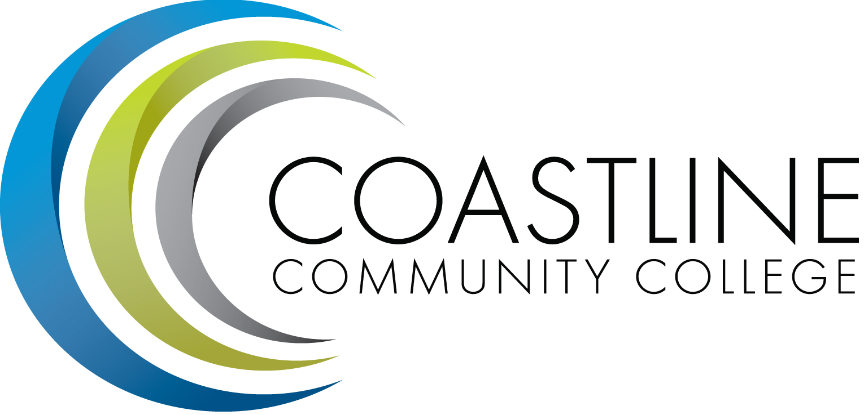

ACADEMIC SENATE
April 17, 2018 12:30 p.m. - 2:30 p.m.
College Center--Fourth Floor Conference Room
AGENDA
College Mission Statement: Coastline Community College steadfastly focuses on providing access and supporting student success and achievement. Inspired by an innovative and student-centered mindset, Coastline delivers flexible courses and services that cultivate and guide diverse student populations across the globe to complete pathways leading to the attainment of associate degrees, certificates, career readiness, and transfer to four-year colleges/universities.

12:30 p.m. 1. CALL TO ORDER: President Stephen Barnes
1.1 Pledge of Allegiance
1.2 Roll Call
1.3 Welcome
1.4 Adopt Agenda
1.5 Approval of Minutes – April 3, 2018**
1.6 Consent Calendar
1.6.1 Faculty Oceana Callum, Tanya Murray, Erin Johnson, Stephen Barnes, Stacey Smith, and Hao Nhien Vu to serve on Master Courses Focus Group
1.7 Public Comment and Statement: Members of the public can address the Academic Senators on any item that has been described in this notice, before or during consideration of the item. Persons wishing to make comments are allowed three minutes.

2. SPECIAL PRESENTATION
2.1 Block Scheduling – Dr. Shelly Blair
2.2 Part Time Load – Dr. Vince Rodriguez

3. DISCUSSION AND ACTION
3.1 Senate Exec. Elections – Margaret Lovig
3.2 Participatory Governance Document* – Stephen Barnes
3.3 Guided Pathways Coordinator Revised Description** – Stephen Barnes
3.4 FSC Coordinator Revised Description** – Stephen Barnes

4. DISCUSSION ITEMS
4.1 RSI Task Force

5. COLLEGE COMMITTEE REPORTS
5.1 PIEAC – Stephen Barnes
5.2 Budget – Rick Lockwood
5.3 Facilities – Michael Warner
5.4 Technology – Cheryl Chapman
5.5 Professional Development & Leadership – Lisa Lee
5.6 Student Success – Ann Holliday
5.7 Curriculum – Deborah Henry
5.8 Accreditation – Danny Pittaway

6. SENATE SUBCOMMITTEE REPORTS
6.1 Academic Rank – Michael Warner
6.2 Academic Standards – Ann Holliday
6.3 Budget – Ann Holliday
6.4 Communications – David Lee
6.5 Elections – Margaret Lovig
6.6 Faculty Recognition – Ann Holliday
6.7 FSC – Rick Lockwood, Cheryl Chapman
6.8 Policy and Procedures – Deborah Henry
6.9 Social – David Lee

7. ANNOUNCEMENTS: (1-minute limit – please sign list to speak)

2:30 p.m. 8. ADJOURNMENT

*Hand-outs available at meeting.
**Copies have been sent to Senators. Others who would like a copy should contact the Senate office at academicsenate@coastline.edu.

Refreshments
Kevin Erdkamp & Michael Warner

Contact the Senate Office ~~ We welcome your input!
Stephen Barnes (714) 241-6156 ~~ Email: academicsenate@coastline.edu
Academic Senate Website: Academic Senate Website
Zoom Link: https://zoom.us/j/619853943

NOTES AND NEWS
Stephen Barnes, Academic Senate President
April 17, 2018
- 3rd Annual Spring Dance | Newport Beach Campus, 1st Floor Alcove; 6:00pm – 9:00pm. Live DJ, games, and refreshments. Please contact Kasie Hipp @ ext. 16253 for more information.
- Classified Senate Spring Fundraiser | Friday, April 20, 2018; 8am – 1pm. Donuts and Coffee for sale at College Center. For more information please contact Maria Hernandez Figueroa @ ext. 16427
- Scholarship Ceremony | Thursday, May 3, 2018; 6pm – 9pm. Orange Coast College, Robert Moore Theater. Please contact Nathan Brais @ ext. 16134 for more information.
- End-of-Year Event for Newport Beach Campus | Monday, May 7, 2018. Free food catered by OCC catering. Please contact Kasie Hipp @ ext.16253 for more information.
- Academic Senate Luncheon | Tuesday, May 15, 2018. Garden Grove Campus, Room 315; 12:30pm – 2:30pm. Please RSVP to ylopez@coastline.edu. Please send $15 cash/check to Academic Senate Office.
- Intellectual Disabilities (ID) Program Art and Music Night | Friday, May 18, 2018; 5pm – 7:30pm. Newport Beach Campus in the Art Gallery. Music will be outside, on the first floor. Light refreshments will be served. For more information please contact Lisa Winger @ ext. 17216.
- ASGCCC Installation Dinner | Friday, May 25, 2018. Newport Beach Campus; 5:30pm – 7:30pm. Banquet style dinner and ceremony.
- Memorial Day: Monday, May 28, 2018 | All campuses closed.
- 2018 Commencement Ceremony | Friday, June 1, 2018; 4pm. Orange Coast College, Robert Moore Theater.

NEXT MEETING
Date: May 1, 2018
Refreshments: Fred Curry, Danny Pittaway

